**Develop a scientific calculator to perform arithmetic and mathematical functions using Math class. [Your scientific calculator should contain +, *, /, =, cos, sin, tan, pow, sqrt, log, Natural Log and mod].**

**AIM:**

**To develop an android application for a scientific calculator to perform arithmetic and mathematical functions using Math class.**

**PROCEDURE:**

**Step 1: File → NewProject Provide the application name and Click “Next”**

**Step 2: Select the target android devices, Select the minimum SDK to run the application. Click “Next”.**

**Step 3: Choose the activity for the application (By default choose “Blank Activity). Click “Next”.**

**Step 4: Enter activity name and click "Finish".**

**Step 5: Edit the program. Step 6: Run the application, 2-ways to run the application 1. Running through emulator 2. Running through mobile device**

**CODE:**

**AndroidManifest.xml:**

**<?xml version="1.0" encoding="utf-8"?>**

**<androidx.constraintlayout.widget.ConstraintLayout**

**xmlns:android="http://schemas.android.com/apk/res/android"**

**xmlns:app="http://schemas.android.com/apk/res-auto"**

**xmlns:tools="http://schemas.android.com/tools"**

**android:layout_width="match_parent"**

**android:layout_height="match_parent"**

**tools:context=".MainActivity">**

**<TextView**

**android:id="@+id/display"**

**android:layout_width="0dp"**

**android:layout_height="wrap_content"**

**android:layout_margin="16dp"**

**android:background="@android:color/darker_gray"**

**android:gravity="end"**

**android:padding="16dp"**

**android:text="0"**

**android:textColor="@android:color/black"**

**android:textSize="24sp"**

**app:layout_constraintTop_toTopOf="parent"**

**app:layout_constraintStart_toStartOf="parent"**

**app:layout_constraintEnd_toEndOf="parent" />**

**<GridLayout**

**android:id="@+id/gridLayout"**

**android:layout_width="0dp"**

**android:layout_height="0dp"**

**android:layout_margin="16dp"**

**android:alignmentMode="alignMargins"**

**android:columnCount="4"**

**android:rowCount="5"**

**app:layout_constraintTop_toBottomOf="@id/display"**

**app:layout_constraintStart_toStartOf="parent"**

**app:layout_constraintEnd_toEndOf="parent"**

**app:layout_constraintBottom_toBottomOf="parent">**

**<!-- Buttons for the calculator -->**

**<Button android:id="@+id/btn7" android:text="7" android:layout_width="0dp" android:layout_height="wrap_content" />**

**<Button android:id="@+id/btn8" android:text="8" android:layout_width="0dp" android:layout_height="wrap_content" />**

**<Button android:id="@+id/btn9" android:text="9" android:layout_width="0dp" android:layout_height="wrap_content" />**

**<Button android:id="@+id/btnDiv" android:text="/" android:layout_width="0dp" android:layout_height="wrap_content" />**

**<Button android:id="@+id/btn4" android:text="4" android:layout_width="0dp" android:layout_height="wrap_content" />**

**<Button android:id="@+id/btn5" android:text="5" android:layout_width="0dp" android:layout_height="wrap_content" />**

**<Button android:id="@+id/btn6" android:text="6" android:layout_width="0dp" android:layout_height="wrap_content" />**

**<Button android:id="@+id/btnMul" android:text="*" android:layout_width="0dp" android:layout_height="wrap_content" />**

**<Button android:id="@+id/btn1" android:text="1" android:layout_width="0dp" android:layout_height="wrap_content" />**

**<Button android:id="@+id/btn2" android:text="2" android:layout_width="0dp" android:layout_height="wrap_content" />**

**<Button android:id="@+id/btn3" android:text="3" android:layout_width="0dp" android:layout_height="wrap_content" />**

**<Button android:id="@+id/btnSub" android:text="-" android:layout_width="0dp" android:layout_height="wrap_content" />**

**<Button android:id="@+id/btn0" android:text="0" android:layout_width="0dp" android:layout_height="wrap_content" />**

**<Button android:id="@+id/btnDot" android:text="." android:layout_width="0dp" android:layout_height="wrap_content" />**

**<Button android:id="@+id/btnEqual" android:text="=" android:layout_width="0dp" android:layout_height="wrap_content" />**

**<Button android:id="@+id/btnAdd" android:text="+" android:layout_width="0dp" android:layout_height="wrap_content" />**

**<Button android:id="@+id/btnCos" android:text="cos" android:layout_width="0dp" android:layout_height="wrap_content" />**

**<Button android:id="@+id/btnSin" android:text="sin" android:layout_width="0dp" android:layout_height="wrap_content" />**

**<Button android:id="@+id/btnTan" android:text="tan" android:layout_width="0dp" android:layout_height="wrap_content" />**

**<Button android:id="@+id/btnSqrt" android:text="√" android:layout_width="0dp" android:layout_height="wrap_content" />**

**<Button android:id="@+id/btnPow" android:text="^" android:layout_width="0dp" android:layout_height="wrap_content" />**

**<Button android:id="@+id/btnLog" android:text="log" android:layout_width="0dp" android:layout_height="wrap_content" />**

**<Button android:id="@+id/btnLn" android:text="ln" android:layout_width="0dp" android:layout_height="wrap_content" />**

**<Button android:id="@+id/btnMod" android:text="%" android:layout_width="0dp" android:layout_height="wrap_content" />**

**</GridLayout>**

**</androidx.constraintlayout.widget.ConstraintLayout>**

**MainActivity.java:**

**package com.example.scientificcalculatorapp;**

**import android.os.Bundle;**

**import android.view.View;**

**import android.widget.Button;**

**import android.widget.TextView;**

**import androidx.appcompat.app.AppCompatActivity;**

**public class MainActivity extends AppCompatActivity {**

**private TextView display;**

**private StringBuilder input = new StringBuilder();**

**private double result = 0;**

**private String operator = "";**

**@Override**

**protected void onCreate(Bundle savedInstanceState) {**

**super.onCreate(savedInstanceState);**

**setContentView(R.layout.activity_main);**

**display = findViewById(R.id.display);**

**// Set up button listeners**

**setButtonListeners();**

**}**

**private void setButtonListeners() {**

**int[] buttons = {R.id.btn0, R.id.btn1, R.id.btn2, R.id.btn3, R.id.btn4,**

**R.id.btn5, R.id.btn6, R.id.btn7, R.id.btn8, R.id.btn9,**

**R.id.btnAdd, R.id.btnSub, R.id.btnMul, R.id.btnDiv, R.id.btnEqual,**

**R.id.btnCos, R.id.btnSin, R.id.btnTan, R.id.btnPow, R.id.btnSqrt,**

**R.id.btnLog, R.id.btnLn, R.id.btnMod, R.id.btnDot};**

**for (int id : buttons) {**

**Button button = findViewById(id);**

**button.setOnClickListener(this::onButtonClick);**

**}**

**}**

**private void onButtonClick(View view) {**

**Button button = (Button) view;**

**String value = button.getText().toString();**

**switch (value) {**

**case "+":**

**case "-":**

**case "*":**

**case "/":**

**case "%":**

**case "^":**

**operator = value;**

**result = Double.parseDouble(input.toString());**

**input.setLength(0);**

**break;**

**case "=":**

**double secondOperand = Double.parseDouble(input.toString());**

**switch (operator) {**

**case "+": result += secondOperand; break;**

**case "-": result -= secondOperand; break;**

**case "*": result *= secondOperand; break;**

**case "/": result /= secondOperand; break;**

**case "%": result %= secondOperand; break;**

**case "^": result = Math.pow(result, secondOperand); break;**

**}**

**display.setText(String.valueOf(result));**

**input.setLength(0);**

**break;**

**case "cos":**

**result = Math.cos(Math.toRadians(Double.parseDouble(input.toString())));**

**display.setText(String.valueOf(result));**

**input.setLength(0);**

**break;**

**case "sin":**

**result = Math.sin(Math.toRadians(Double.parseDouble(input.toString())));**

**display.setText(String.valueOf(result));**

**input.setLength(0);**

**break;**

**case "tan":**

**result = Math.tan(Math.toRadians(Double.parseDouble(input.toString())));**

**display.setText(String.valueOf(result));**

**input.setLength(0);**

**break;**

**case "√":**

**result = Math.sqrt(Double.parseDouble(input.toString()));**

**display.setText(String.valueOf(result));**

**input.setLength(0);**

**break;**

**case "log**

**OUTPUT:**

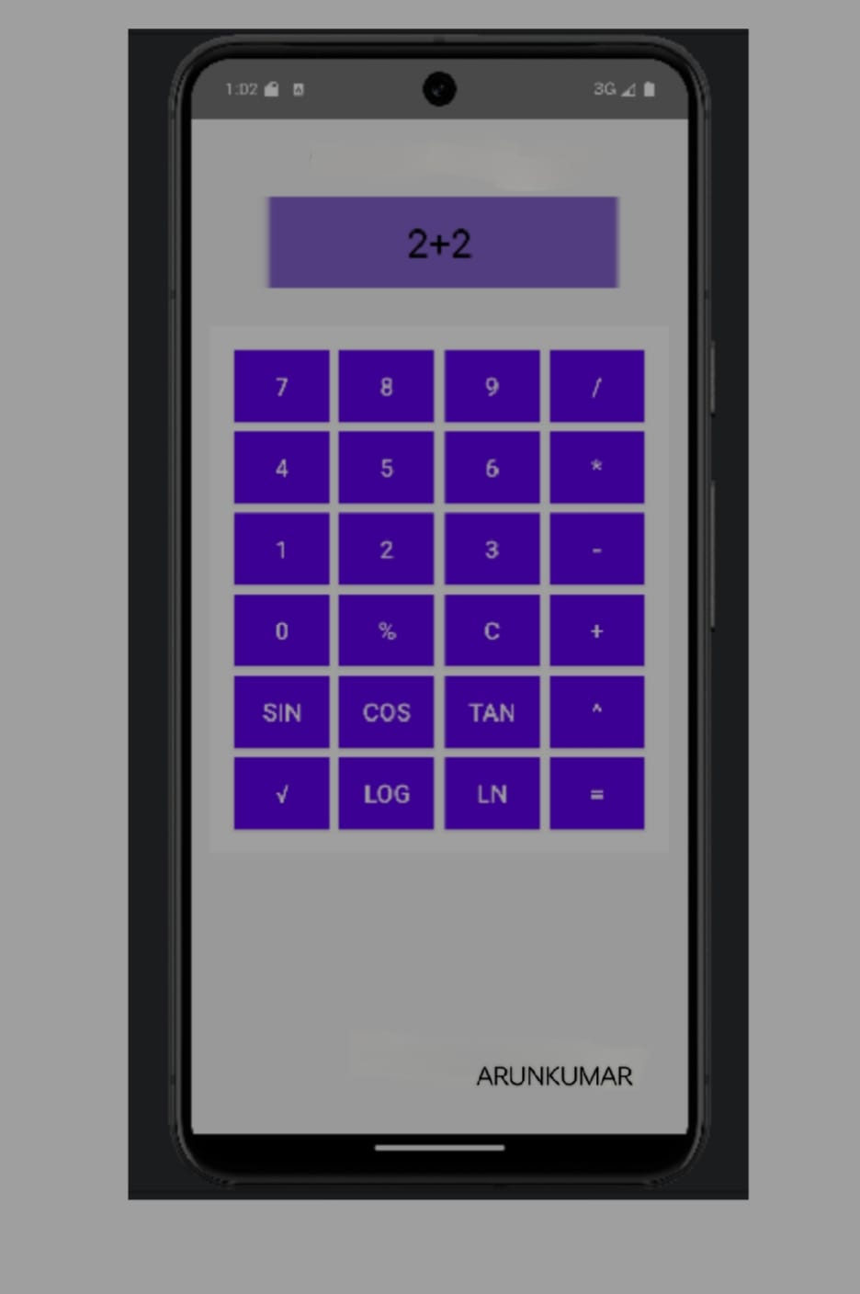

**RESULT:**

**Thus the program is created and executed successfully.**